**Cryptography & Network Security Lab**

**PRN/ Roll No: 2019BTECS00090**

**Full name: Udaykumar Gadikar**

**Assignment No. 11**

**Title: Diffie-Hellman Key Exchange**

**Aim: To Demonstrate Diffie-Hellman Key Exchange**

**Theory:**

**Diffie–Hellman key exchange is a method of securely exchanging cryptographic keys over a public channel and was one of the first public-key protocols as conceived by Ralph Merkle and named after Whitfield Diffie and Martin Hellman.**

**Code:**

**Client side Code: -**

import socket

import os

def power(a, b, P):

    if (b == 1):

        return a

    else:

        return ((pow(a, b)) % P)

def generation_alpha(i, P):

    l = []

    for j in range(2, P-1):

        c1 = power(i, j, P)

        if l.count(c1) == 1:

            return False

        l.append(c1)

    return True

print("************CLIENT PROGRAM STARTED ******************")

s = socket.socket()

host = socket.gethostname()  # server hostname

#host='127.0.0.1'

port = 12000  # same as server

s.connect((host, port))

print("Connected to : ", host, port)

# fileToSend = open("ToSend.txt","r")

# content = fileToSend.read()

P = 941

q_alpha=0

for i in range(2, P-1):

    if (generation_alpha(i, P)):

        q_alpha = i

        break

b = int(input('Enter Your private Key: '))

y = power(q_alpha, b, P)

s.send(str(y).encode())

x = int(s.recv(100).decode())

kb = power(x, b, P)

print('Secret Key of Bob: ', kb)

print("************CLIENT PROGRAM ENDED ******************")

# private key - 347

**Server side Code : -**

import socket

import os

import sys

def power(a, b, P):

    if (b == 1):

        return a

    else:

        return ((pow(a, b)) % P)

def generation_alpha(i, P):

    l = []

    for j in range(2, P-1):

        c1 = power(i, j, P)

        if l.count(c1) == 1:

            return False

        l.append(c1)

    return True

print("***********SERVER PROGRAM STARTED ***********")

s = socket.socket()

host = socket.gethostname()

#host='127.0.0.1'

port = 12000  # ports after 6000 are free

s.bind((host, port))

s.listen(10)

P = 941

q_alpha=0

for i in range(2, P-1):

    if (generation_alpha(i, P)):

        q_alpha = i

        break

while True:

    c, addr = s.accept()

    print("Client connected", addr)

    print('Got Connection from', addr)

    a = int(input('Enter Your private Key: '))

    x = power(q_alpha, a, P)

    y = int(c.recv(100).decode())

    if not y:

        break

    c.send(str(x).encode())

    ka = power(y, a, P)  # Secret key for Alice

    print('Secret Key of Alice: ', ka)

    break

print("**********SERVER PROGRAM ENDED *************")

# private key - 781

**Output:**

**Server side Output: -**

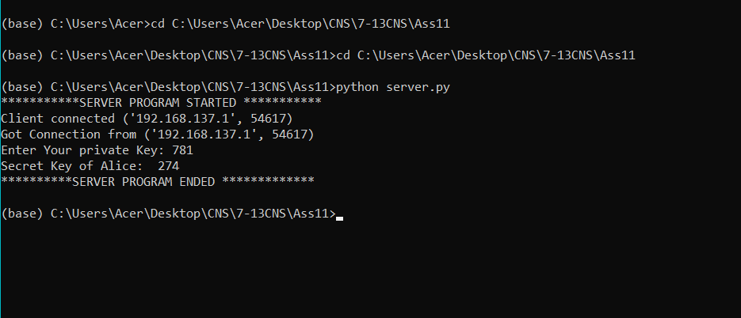

**Client side Output :-**

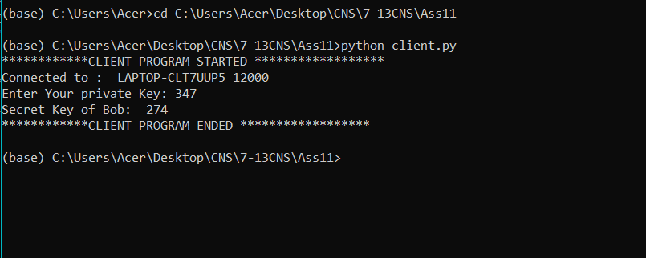

**Conclusion:**

**The Diffie–Hellman key exchange method allows two parties that have no prior knowledge of each other to jointly establish a shared secret key over an insecure channel. This key can then be used to encrypt subsequent communications using a symmetric-key cipher.**